Seminarium Zakładu Energetyki Jądrowej i Analiz Środowiska (UZ3)
Departament Badań Układów Złożonych (DUZ)
Wtorek: 30.01.2024, godz. 11:30

Seminarium hybrydowe: sala EWA, PNT

transmisja online: https://www.gotomeet.me/NCBJmeetings/uz3-and-phd4gen-seminars

dr Afaque Shams
KFUPM

The Importance of High-fidelity Numerical Simulations for Nuclear Reactor Design and Safety

Abstract:

Large-scale computations play a crucial role in numerous engineering and scientific applications, especially in the nuclear field, where the demand for accurate simulations and reliable reference data for validation purposes underscores the significance of high-fidelity simulations. Given the substantial computational resources required, these simulations necessitate dedicated computational facilities. This presentation will highlight the vital role of high-fidelity numerical simulations, specifically Direct Numerical Simulation (DNS), in facilitating the design and safety analyses of nuclear fission reactors.

To exemplify this, a Direct Numerical Simulation (DNS) is conducted using a high-order spectral element method to analyze flow and thermal fields in a Pressurized Thermal Shock (PTS) scenario. The chosen configuration represents a simplified reactor pressure vessel. Cold water is introduced from a square duct, impacting the downcomer wall containing the hot water. Mixing between the cold and hot water occurs in the downcomer. The friction Reynolds number in the inlet duct is 180, with a unitary Prandtl number for the fluid. The thermal field is addressed by imposing two different boundary conditions: isothermal and adiabatic, representing extreme scenarios of a conjugate heat transfer problem. A meticulous meshing strategy is employed, and post-analysis verification ensures the mesh resolution meets high-quality DNS. These simulations are performed using the HPC facility at the Świerk Computing Centre (CIŚ), NCBJ, Poland.

Serdecznie zapraszamy
Mariusz Dąbrowski, Tomasz Kwiatkowski

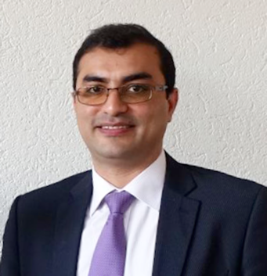
Bio:
Afaque Shams is an Associate Professor in the Mechanical Engineering Department at King Fahd University of Petroleum and Minerals (KFUPM), Saudi Arabia. Additionally, he serves as the coordinator of nuclear initiatives at KFUPM. Possessing both an MSc and PhD in Computational Fluid Dynamics, Shams is deeply passionate about his role as a thermal-hydraulic expert within the nuclear community.

Thanks to his vast range of expertise, he enjoys working on a variety of nuclear reactor designs. His research interests center around turbulence modeling, high-fidelity simulations, fluid-structure interaction, numerical methods, and high-performance computing. Notably, he holds a keen focus on the numerical modeling of turbulent heat transfer in liquid metal flows. His commitment to advancing knowledge in these areas is evident in his extensive body of work, comprising over a hundred peer-reviewed scientific publications.

